The Varsity football game on Friday, September 9 was used to pay tribute to the 10th anniversary of the September 11, 2001 attacks on the World Trade Center, Pentagon, & Flight 93. In addition special recognition was given to Bravo Battery, 1/134th Field Artillery National Guard Unit of Piqua. The following pictures were taken that night.
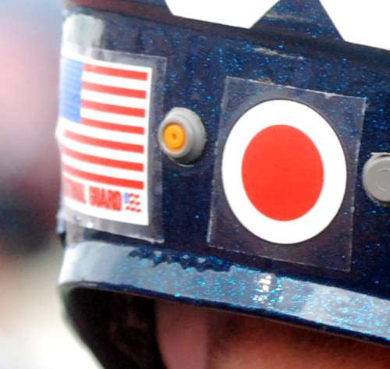
National Guard logo & flag on the
back of all Piqua helmets.

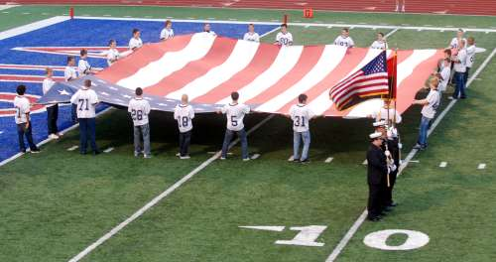
9th Football team members unfurl the American flag during
the Sept. 11 tribute and National Anthem during pregame.

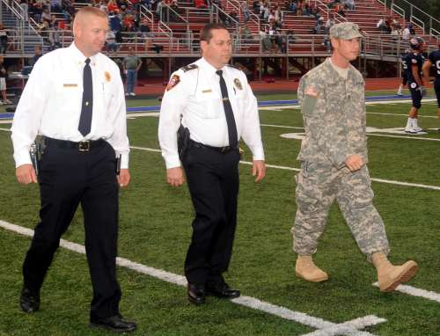

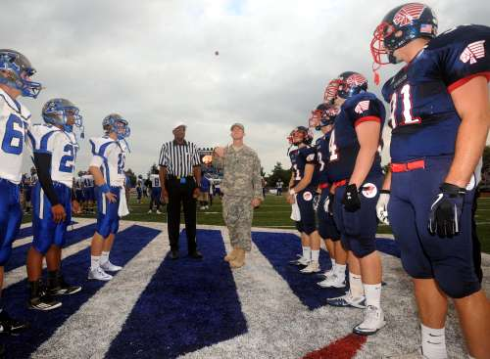

Fire Chief Mike Rindler, Police Chief Bruce Jamison & Staff Sgt. Jon Voisinet participated in the coin toss prior to the game with Xenia.

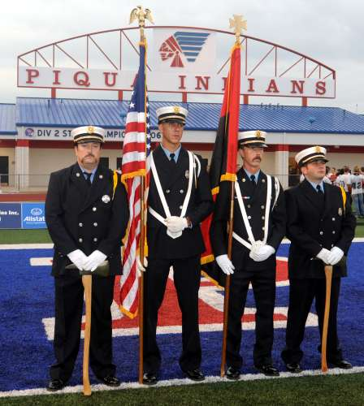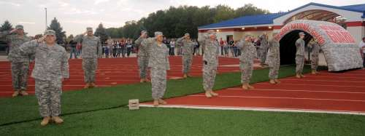
Fire Dept. Honor Guard

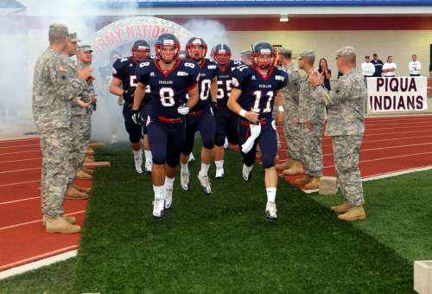
Members of Bravo Battery cheer as Piqua takes the field.

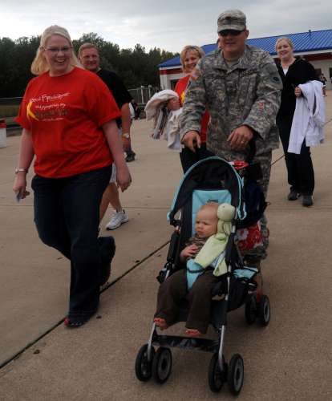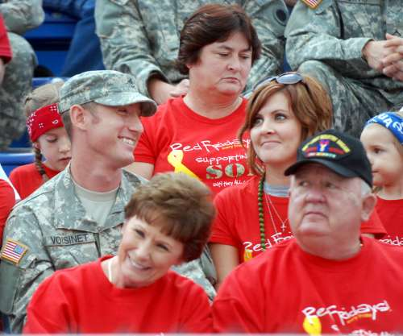
All the members of Bravo Battery and their families were invited to attend as our special guest. VIP seating on the fifty yard line was designated for Bravo Battery. The Piqua Athletic Boosters provide them with complimentary food throughout the game. 71 members of Bravo Battery, 1/134th Field Artillery National Guard Unit of Piqua attended the game on September 9th.

Commemorative program cover for the game honors Bravo Battery, Police, Fire & other military branches.

