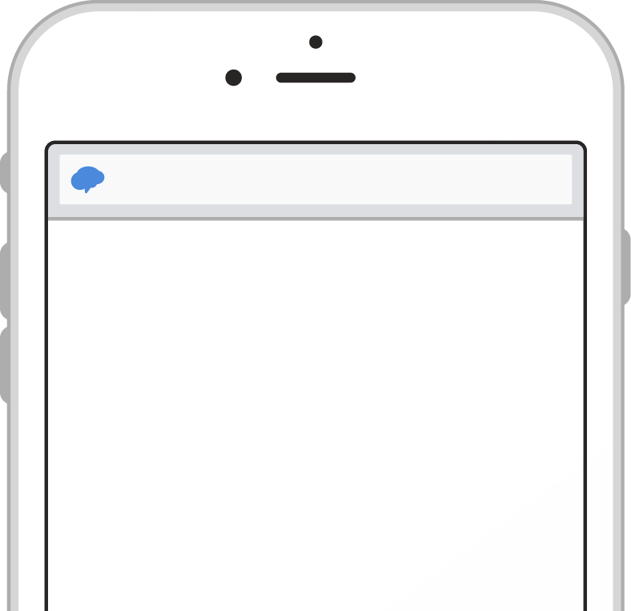
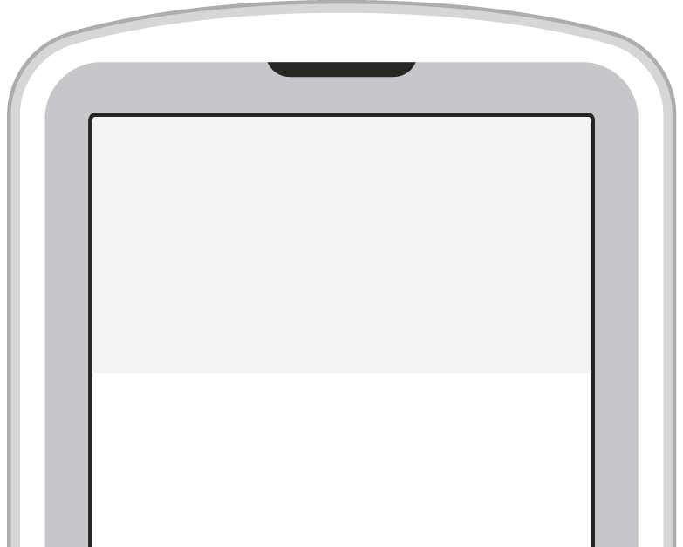
Pick a way to receive messages for 2020-21 Mrs. Kalb Homeroom:
A If you have a smartphone, get push notifications.

On your iPhone or Android phone,
open your web browser and go to rmd.at/4496h6 the following link:
Join 2020-21 Mrs. Kalb rmd.at/4496h6 Homeroom
Full Name
Follow the instructions to sign up First and Last Name
for Remind. You’ll be prompted to
download the mobile app. Phone Number or Email Address
(555) 555-5555

B If you don’t have a smartphone, get text notifications.

Text the message @4496h6 to the number To
81010. 81010

If you’re having trouble with 81010, try
texting @4496h6 to (509) 572-3828. Message
* Standard text message rates apply. @4496h6

Sign up for important updates from Jake Molyet and Mrs. Kalb.

Get information for Mohawk Elementary School right on your phone—not on handouts.

Don’t have a mobile phone? Go to rmd.at/4496h6 on a desktop computer to sign up for email notifications.

